27.9:
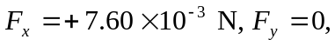and 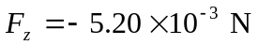
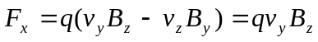
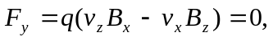 which is consistent with 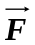as given in the problem. No force component along the direction of the velocity.
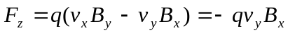
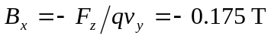
b) 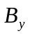is not determined. No force due to this component of 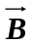along 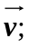 measurement of the force tells us nothing about 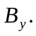
c)

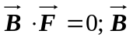and are perpendicular (angle is 